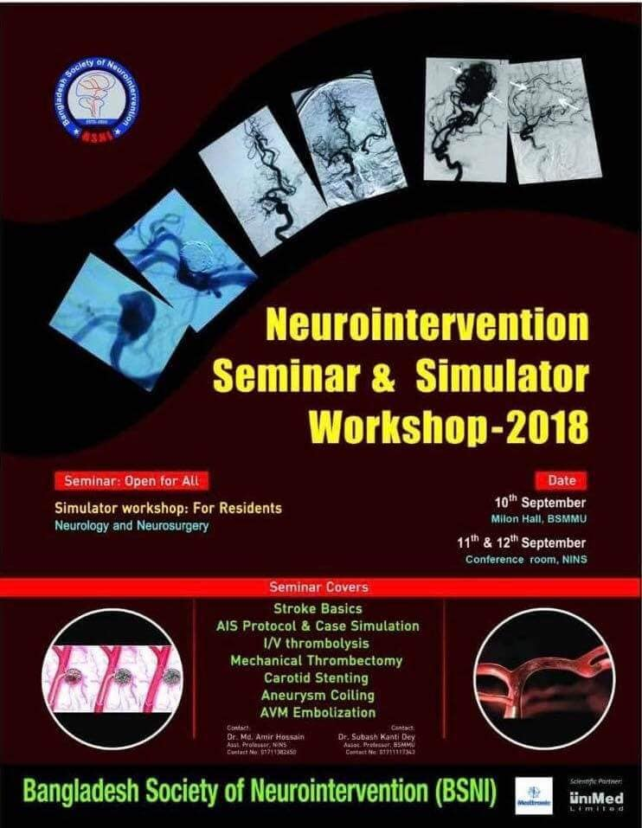
It was a great challenge and moment of happiness to successfully organize the Neurointervention Seminar & Simulator Workshop-2018 within a very short notice from 10th to 12th September, 2018 at Bangabandhu Sheikh Mujib Medical University (BSMMU) and National Institute of Neurosciences and Hospital (NINS) jointly organized by Bangladesh Society of Neurointervention (BSNI), Unitrade Unimed Ltd, Bangladesh and Medtronic, India. The simulator setup was provided by Medtronic, India.
The seminar was arranged to provide the young neurointerventionists basic anatomic and pathologic aspect of diseases related to Interventional Neurology and to give them a real time opportunity to practice their skill in simulator devices. The enriched academic lectures were given by our faculties from different intitutions. Prof. Sharif Uddin Khan, Prof. Kazi Mohibur Rahman, Dr. Sirajee Shafiqul islam, Dr. Khairul Kabir Patwary and Dr. Dewan Md. Elyas, Dr. M Amir Hossain, Dr. M A Momen Khan, Dr. A T M Hasibul Hasan, Dr. Bakhtiar Azam from national Institute of Neurosciences and Hospital; Dr. Subash Kanti Dey, Dr. Md Shahidullah, Dr. Anis Ahmed from Bangabandhu Sheikh Mujib Medical University, Dr. Farzana Alam (Radiologist) from Dhaka Medical College & Hospital and Dr. M Aminur Rahman from Sir Salimullah Medical College & Mitford Hospital were there as faculties. More than hundred residents and trainees registered for the hands on material workshop and simulator practice. We divided them into three groups for the purpose of proper time on hands on.
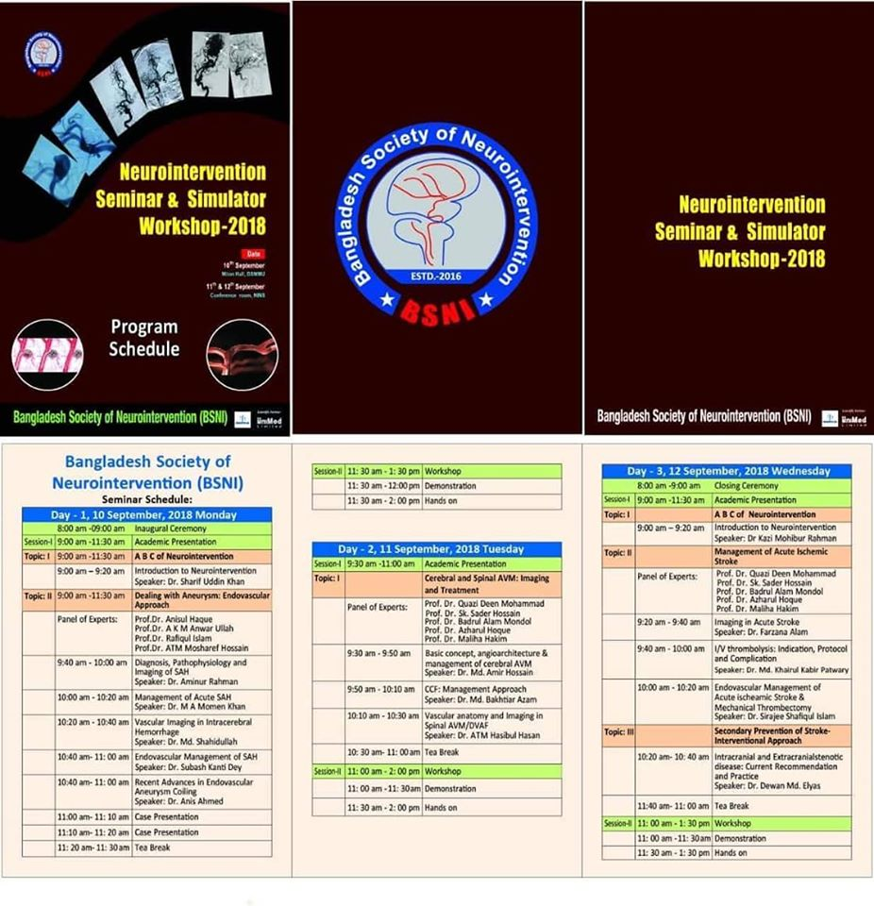

The three day seminar had two sessions per day. The venue was Millon Hall, BSMMU on the first day and Conference room, NINS on subsequent days. The simulator workshop was arranged on first day at Millon Hall, BSMMU and next two days at Cathlab, NINS.
Day 1:
The program was inaugurated by the Honorable Vice Chancellor, Prof. Kanak Kanti Barua. After a short inauguration the scientific session started with the topic “ABS of Neurointervention” by Prof. Sharif Uddin Khan. The next topic was “Dealing with aneurysms: endovascular approach”. On this topic Dr. Aminur Rahman spoke about “Diagnosis, Pathophysiology and Imaging of SAH”. Dr. M A Momen Khan discussed on “Management of Acute SAH”. Dr. Md Shahidullah showed “Vascular Imaging in Intracerebral Hemorrhage”. Dr. Subash Kanti Dey presented on “Endovascular Management of SAH”. The session ended with Dr. Anis Ahmed who spoke on “Recent advances in endovascular coiling”.
After the tea break in the second session there was simulator and material workshop where the residents and trainees got the opportunity to learn about different tools used for neuroinetrventional purposes. This was a very lively interactive session with the generous participation of the registrants.
Day 2:
The second day was dedicated to Cerebral and spinal AVM. Dr. M Amir Hossain gave an in depth review of the “Basic concept, functional anatomy and imaging of cerebral AVM”. Dr. Md Bakhtiar Azam spoke about the “Management approach in CCF”. Lastly, Dr. A T M Hasibul Hasan made a robust discussion on “Vascular anatomy and Imaging in Spinal AVM/DVAF”. The day ended again with simulator workshop for the participant.
Day 3:
On the final day, it was all about the Ischemic Stroke. The first topic was Management of Acute Ischemic Stroke. Dr. Farzan Alam started the academic session with “Imaging in Acute Stroke”. Dr. Md Khairul Kabir Patwary gave an insight to “I/V thrombolysis: Indication, Protocol and Complication”. Dr. Sirajee Shafiqul Islam showed “Endovascular Management of Acute Ischemic Stroke --Mechanical Thrombectomy”. The last topic of the seminar was Secondary Prevention of Stroke- Interventional Approach. Dr Dewan Md Elyas made a presentation on “Intracranial and Extracranial stenotic disease: Current Recommendation and Practice”. After that the participants got their last chance to gain hands on material workshop.

